**Assignment 9.3**

**Question:** Create two datasets employee and department of file type text where the columns are delimited by tab (‘\t’), and use these datasets to perform below Join operations.

● SELF JOIN

● INNER JOIN

● LEFT OUTER JOIN

● RIGHT OUTER JOIN

● FULL OUTER JOIN

**INPUT:**

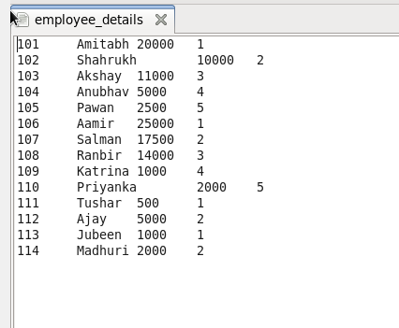

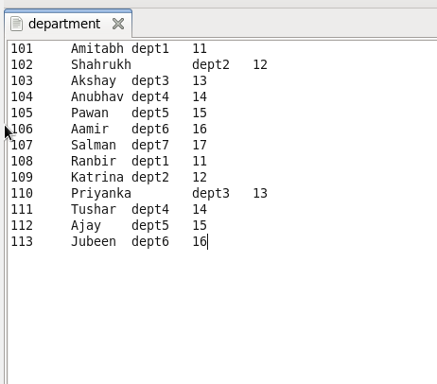

***SELF JOIN:***

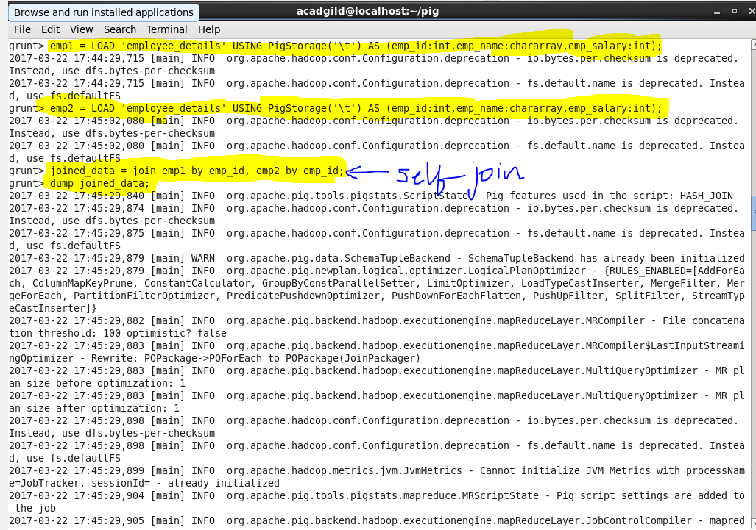

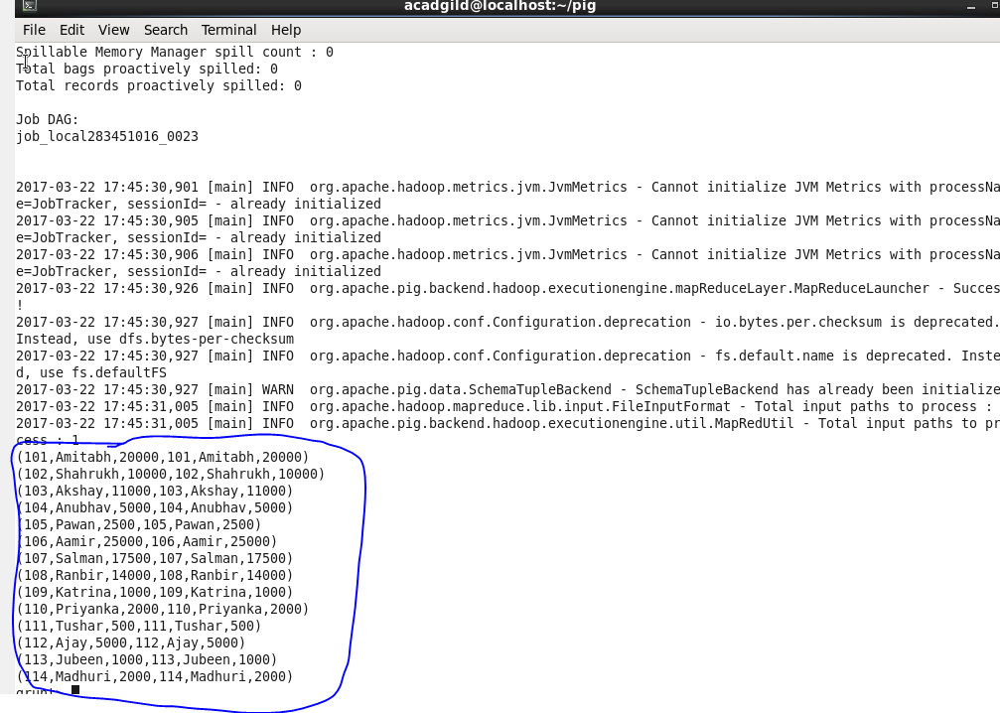

***INNER JOIN:***

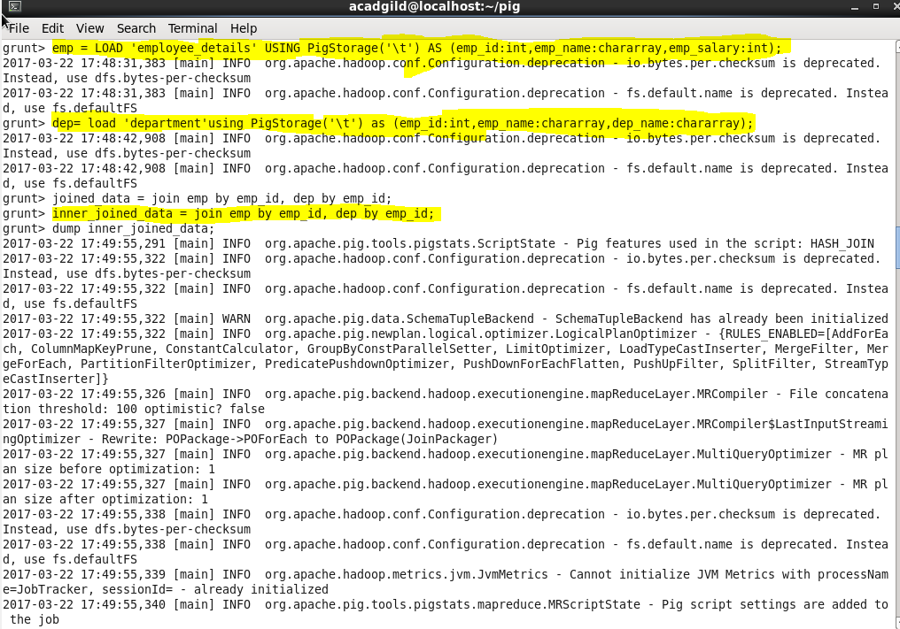

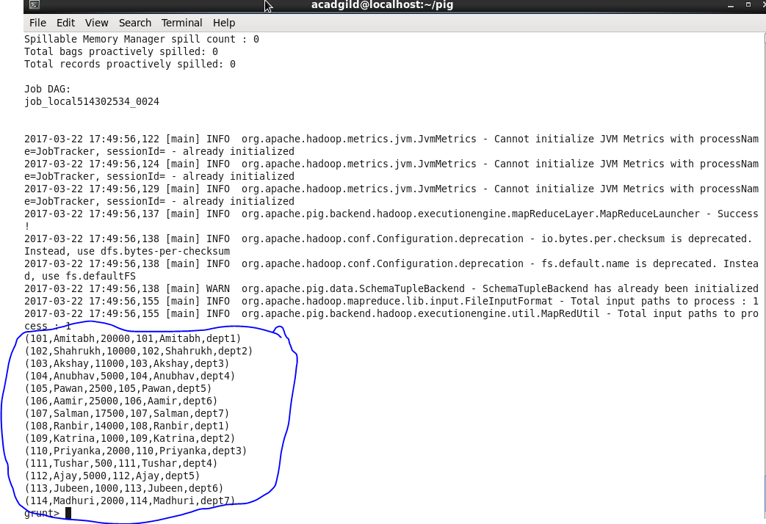

***LEFT OUTER JOIN:*   
  
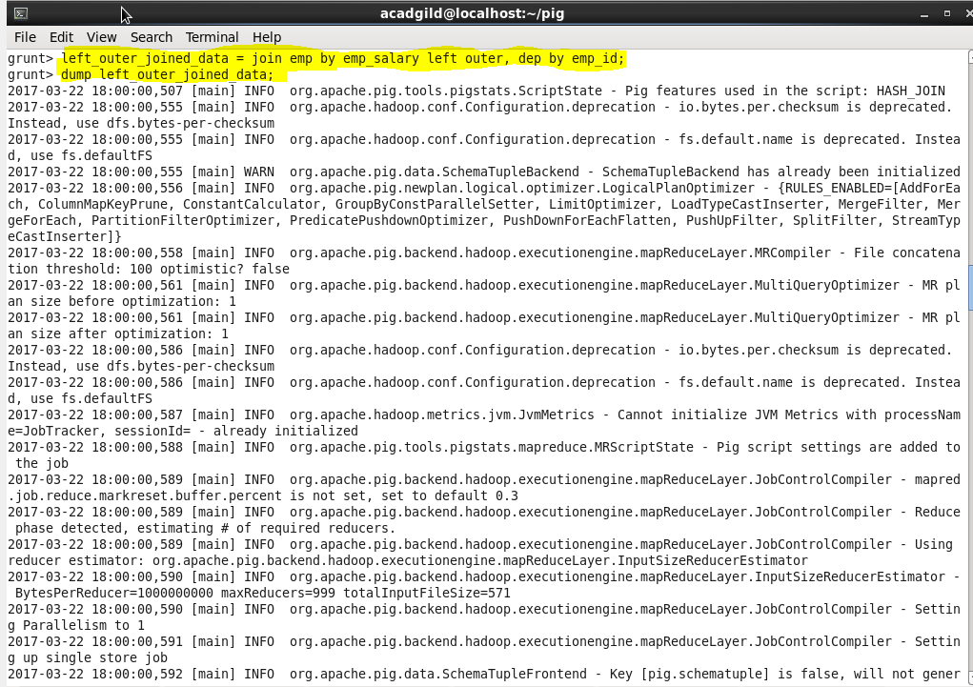**

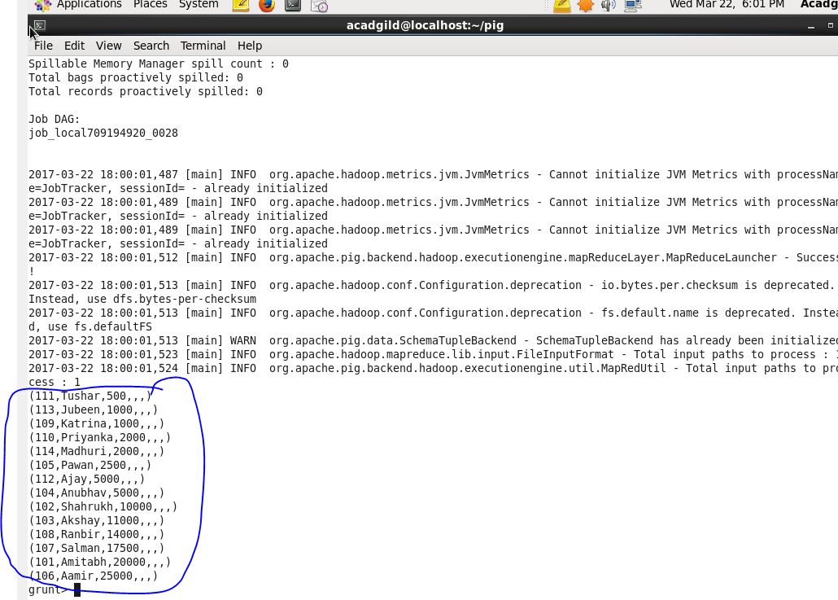

***RIGHT OUTER JOIN:*   
  
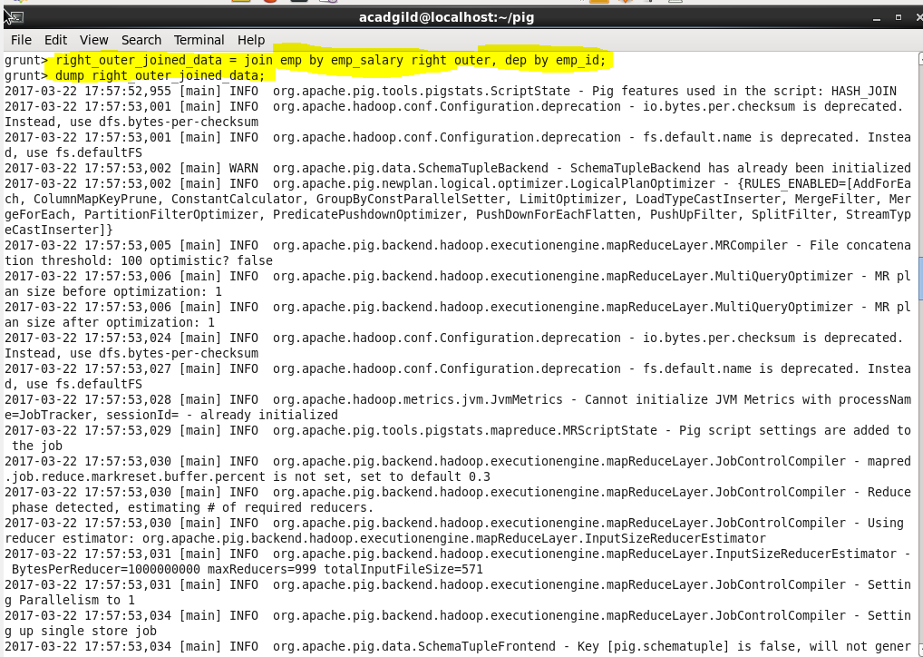**

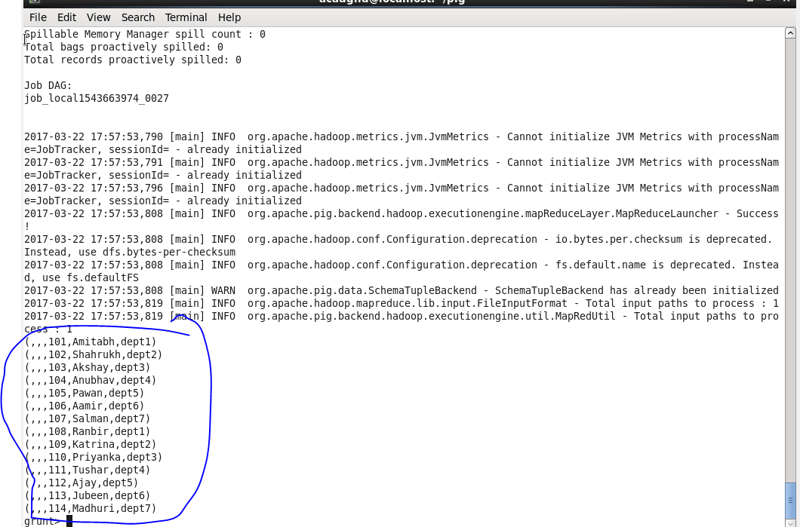

***FULL OUTER JOIN:*   
  
